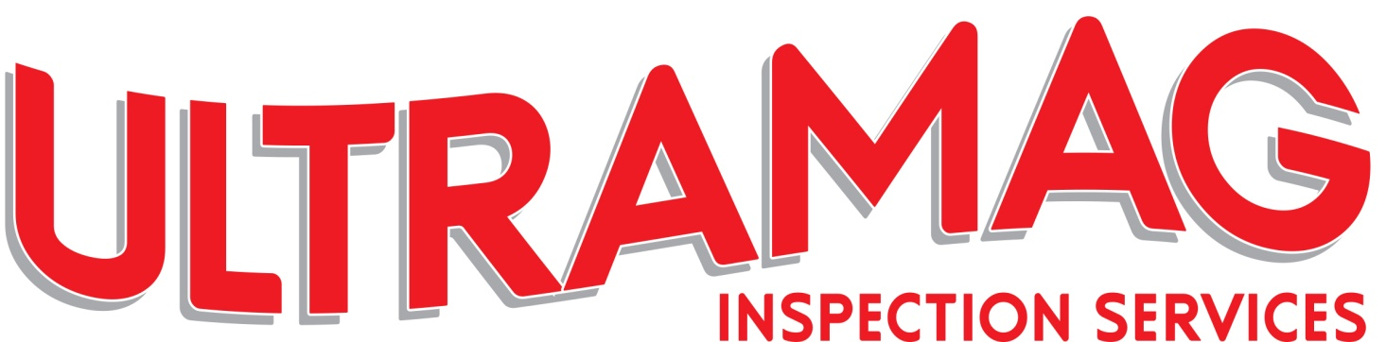

ULTRAMAG INSPECTION SERVICES LTD. CENTRAL CRESCENT, MARCHWOOD INDUSTRIAL PARK, SOUTHAMPTON SO40 4BJ Tel: 023 80861010

|  |
| --- |
| **ON SITE INSPECTION QUESTIONS** |

|  |
| --- |
| **WORK RELATED QUESTIONS** |

|  |
| --- |
| **WHERE IS THE TESTING, ADDRESS INCLUDE POST CODE**  **( MAP AND DIRECTIONS IF POSSIBLE) IS THERE PARKING ON SITE?** |
|  |

|  |
| --- |
| **WHAT TIME ARE WE REQUIRED ON SITE?** |
|  |

|  |
| --- |
| **SITE CONTACT: NAME AND NUMBER (WILL THEY BE ON SITE)?** |
| Name: Number:  Name: Number: |

|  |
| --- |
| **TEST METHOD KNOWN: MPI, DPI, UT, EDDY CURRENT or other** |
|  |

|  |  |  |  |  |  |  |  |
| --- | --- | --- | --- | --- | --- | --- | --- |
| **IF TEST METHOD UNKNOWN: WHAT IS THE MATERIAL?** | | | | | | | |
| Carbon Steel |  | Stainless Steel |  | Aluminium |  | Other |  |

|  |  |  |  |  |
| --- | --- | --- | --- | --- |
| **IS THE MATERIAL BEING TESTED FREE OF CORROSION & COATINGS?** | | | | |
| Yes |  | No |  | Coating may need to be removed for testing |

|  |
| --- |
| **TEST STANDARD REQUIRED? British Standard, ASME, BCSA ( CE or not) etc** |
|  |

|  |
| --- |
| **AMOUNT OF WORK REQUIRED, METRES OF WELDS ( BUTT/FILLET) IF FRAME, SIZE REQUIRED. ANY DRAWINGS OF THE WORK REQUIRED?** |
|  |

|  |  |  |  |  |  |  |  |  |  |  |  |
| --- | --- | --- | --- | --- | --- | --- | --- | --- | --- | --- | --- |
| **GROUND ACCESS OR LIFTING PLATFORM?** | | | | | | | | | | | |
| Ladders |  | Tower |  | Scaffold |  | Scissor Lift |  | Cherry Picker |  | N/A |  |

|  |
| --- |
| **WEATHER CONDITIONS PERMITTING - WILL THE TESTING BE OUTSIDE OR INSIDE?** |
| **Some NDT Methods cannot be performed in rain and/or wet conditions.** |

Continued ...

|  |
| --- |
| **SITE SAFETY REQUIREMENTS** |

|  |
| --- |
| **PPE REQUIRED FOR SITE VISIT, HI VIS, HARD HAT etc. PLEASE LIST ALL. PLEASE INCLUDE IF CSCS OR SAFETY PASSPORT REQUIRED: PLEASE SEE PAGE 3 FOR FULL PPE LIST, PLEASE TICK ACCORDINGLY** |
|  |

|  |
| --- |
| **ANY PERMIT TO WORK REQUIRED, HEIGHTS, CONFINED SPACE, HOT WORKS etc** |
|  |

|  |
| --- |
| **SAFETY INDUCTION REQUIRED? / DRUGS/ALCOHOL TEST REQUIRED** |
|  |

|  |
| --- |
| **ARE R.A.M.S / COSHH REQUIRED( Risk Assessments, Method Statement)** |
|  |
|  |
| **ANY OTHER INFORMATION.** |
|  |

|  |  |  |
| --- | --- | --- |
| **COMPANY:** | **PRINT NAME:** | **DATE:** |
| Form: site questions |

**Please note: Cooling periods required for inspection post welding, should be accounted for when booking a site visit. (8hrs +)**

**Any boxes not completed in full prior to the commencement of the site visit may result in additional charges.**

**Please see Page 4 for details of NDT Surface Condition Requirements.**

**PPE ( PLEASE TICK PPE REQUIRED FOR SITE)**

Body Gear

|  |  |  |
| --- | --- | --- |
| Gloves | Eye Protection | Hardhat |
| Covered Arms | Vest / Waistcoat |  |
| Hi-Vis Class 1 | 2 | Or 3 |
| Hi-Vis Trousers | Boiler Suit / Overalls | Anti-Static |
| Flame Retardant | Chemical Protection |  |

Safety Footwear

|  |  |  |
| --- | --- | --- |
| Shoes | Ankle Boots | Riggers |
| Wellies |  |  |

Hearing

|  |  |  |
| --- | --- | --- |
| Ear Plugs | Ear Defenders |  |

Respiratory

|  |  |  |
| --- | --- | --- |
| Yes | No | (If Yes) Type: |

**NDT SURFACE CONDITION REQUIREMENTS**

**Magnetic Particle Inspection (MPI):**

Areas to be tested (i.e. weld and at least 25mm either side (HAZ) shall be dry unless appropriate products for wet surfaces are being used. It may be necessary to improve the surface condition, e.g. by use of abrasive paper or local grinding to permit accurate interpretation of indications. Any cleaning or surface preparation shall not be detrimental to the material, the surface finish or magnetic testing media.

**Ultrasonic Thickness Measurements (UTM):**

The surface to be measured shall be free of all dirt, grease, lint, scale, welding flux and spatter, oil or other extraneous matter that could interfere with the examination. If painted, the coating shall have good adhesion to the material, otherwise it shall be removed.

**Dye Penetrant Inspection (DPI):**

Contaminants such as scale, rust, oil, grease or paint shall be removed if necessary using mechanical or chemical methods, or a combination of these. Precleaning shall ensure that the test surface is free from residues and that it allows penetrant to enter any discontinuity. The cleaned area shall be large enough to prevent interference from areas adjacent to the actual test surface (i.e. weld and at least 25mm either side (HAZ).

**Eddy Current Testing (ET):**

Eddy current testing can be used to detect surface cracks through non-metallic coatings up to 2mm thick. For effective eddy current testing of welds, it should be noted that local adverse weld form, excessive weld spatter, scale, rust and loose paint can influence sensitivity adversely.